A Minor Project Synopsis on

**“GO AGRO”.**

By Abhinav Jindal

209303239

Under the guidance of

**Dr. Avani Sharma**

**Department of Information Technology**

**School of Computing and Information Technology**

**Manipal University Jaipur**

**Jaipur, Rajasthan**

# Introduction

In agriculture there is lack of use of technologies. Farmers lose their income because they can't find out Crops can be under the influence of various diseases in early stage. If they found out, then they can use fertilizers to save the production of crops. By using technologies like Deep learning, we can find out disease of the plant using their leaves in website. In website we have also included the Fertilizers store and after disease detection we have suggested fertilizer to farmer using API.

It is a web app that consists of three modules- crop recommendation, fertilizer recommendation, and plant disease classification. The crop recommendation module recommends the crop based on the values of the different parameters given by the user. The fertilizer recommendation module suggests how to improve the fertility of the soil. The plant disease classification module helps the farmer to identify the disease.

We have included crop recommendation system in this website. This is developed by machine learning algorithm Random Forest. In this by using N, P, K, Ph of soil and rainfall value of area farmer can easily find out which crop is suitable for his field.

# 2.Motivation

Agriculture is one of the most significant sources of income, employing around 58 percent of our country’s population. According to the 2016-17 Economic Survey, a farmer’s average monthly income in 17 states is Rs.1700/-, resulting in farmer suicides and the conversion of agricultural land for non-agricultural activities. Furthermore, 48% of farmers do not want their children to take care of their farms, preferring to live in cities. The reason for this is that farmers frequently make incorrect crop selection decisions, such as planting in the wrong season or picking a crop that would not yield much for the soil. Incorrect crop selection will always result in a lower yield. It is difficult to survive if the family is entirely dependent on this revenue. Crop yield is affected by different factors such as meteorological, geographic, organic, and economic considerations. It is difficult for farmers to select a suitable crop due to shifting market prices. According to Wikipedia, India’s suicide rate has varied between 1.4 and 1.8 percent per 100,000 people during the last ten years. Due to climate unpredictability, farmers are unsure which crop to cultivate in a particular season. The use of various fertilizers is also unpredictable due to seasonal climate fluctuations and crucial components such as soil, water, and air. Crop yields are progressively dropping in this environment. The solution to the problem is to offer farmers a user-friendly recommender system. In this paper, we offer a model that addresses these concerns. The suggested methodology allows for crop selection based on economic and environmental factors, intending to boost crop yields to satisfy the country’s growing food demand. The proposed model predicts the crop yield by studying factors such as rainfall, temperature, humidity, soil nutrients, ph. value of the soil. The model assists farmers in maintaining soil nutrient levels. In addition to that, the app will enable farmers to identify diseases in their plants.

In India, precision agriculture is not much evaluated. Now a day we found that every day the environment is changing continuously which is harmful to the crops and leading farmers towards debt and suicide. In many cases like this and with growing population to maximize yield farmers are using more pesticides and fertilizers which are leading to the soil infertility as well as decreasing the holding capacity of soil and increasing toxicity of soil. Farming land is used by growing industrialization, so again increasing rate of the soil pollution which affects the quality of plants. Various applications of precision agriculture are prediction of diseases, prediction of weather forecasting, classification of soil, monitoring crop, yield prediction, automatic irrigation system, etc.

# 3.Project objective

**Crop Recommendation** - Based on different parameters, the ML model will predict a suitable crop.

**Fertilizer Recommendation** - Based on different parameters, the ML model will give suggestions to manage the nutrient level in the soil.

**Crop Disease Classification** - The user must give an input image of the infected plant to the ML model and the model classifies the image explaining why the disease has occurred to the plant. It also suggests remedies to cure the plant.

# 4.Methodology

**Dataset**

Data is a crucial part of any Machine Learning System. It is needed to have a certain temperature, humidity, soil pH, sunlight, and soil moisture for a plant to be grown healthy. To receive to good harvest those conditions should be satisfied. But those conditions may vary according to the plant varieties Datasets from various government websites and Kaggle were used to predict the crops. The dataset for the crops recommendation system consists of 22 crops grown across India. Parameters considered for the crop recommendation model are nitrogen, phosphorus, potassium, rainfall, temperature, humidity, ph. Dataset for crop disease classification consists of images of leaves of 14 plants while excluding healthy leaves, 26 types of images that show a particular disease in a plant. For each plant disease type, there are 1800 images.

**Data Exploration**

Data exploration means exploring the relationships between the columns of the dataset. The simple technique to look for correlations between columns is to use a heat map to visualize the correlation matrix. Pearson Correlation is used to visualize the correlation matrix as a heat map.

**Data Splitting**

The input data is segregated into three subsets to prevent the model from overfitting and to evaluate the model effectively. Three subsets are train, valid, and test datasets. Here, we have considered the 60:20:20 ratio which is the most appropriate ratio.

**Architecture**

It shows the system architecture of our proposed model. It is a web app that consists of three modules- crop recommendation, fertilizer recommendation, and plant disease classification. The crop recommendation module recommends the crop based on the values of the different parameters given by the user. The fertilizer recommendation module suggests how to improve the fertility of the soil. The plant disease classification module helps the farmer to identify the disease.

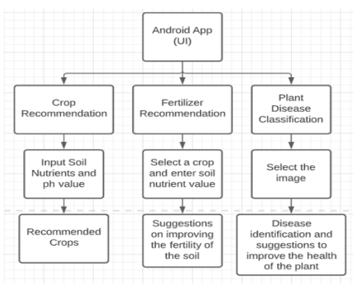

# 5.Resources

The resources used in this project are basic. To implement the project, we will need a system with these specifications-

* Python 3.8.
* Jupyter notebook & VScode
* Python libraries like NumPy, pandas, matplotlib.
* A database of crops, fertilizers, and crop disease images
* Used Heroku for deployment.
* HTML, CSS and JavaScript for frontend and Flask for backend.

# 6. Bibliography

The following resources would be used to gain knowledge about the topic-

* Ensemble Methods - <https://scikit-learn.org/stable/modules/ensemble>
* **ResNet-9** - <https://www.researchgate.net/figure/ResNet-9-architecture-A-convolutional-neural-net-with-9-layers-and-skip-connections_fig1_363585139>
* **Recommendation System** - <https://towardsdatascience.com/recommendation-systems-a-review-d4592b6caf4b>
* **Deployment** - <https://www.geeksforgeeks.org/deploy-python-flask-app-on-heroku/>